Open with Google Drive - Manual
This manual is for opening SpecterX files with Google Drive
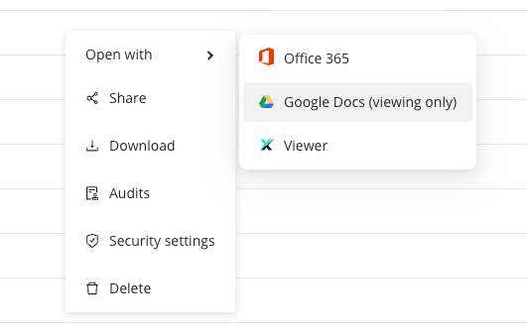

Google Developer console

Create a new project
- In the Google Cloud Platform admin panel, create a new project
- Give it a name with this name convention:
GDrive SA - {customer_name}
(for example GDrive SA - REE)
- Enable APIs for the project (make sure the new project is selected at the top navigation bar - Enable Drive API (check the selected project again, it might change). Make sure you select the newly created project:

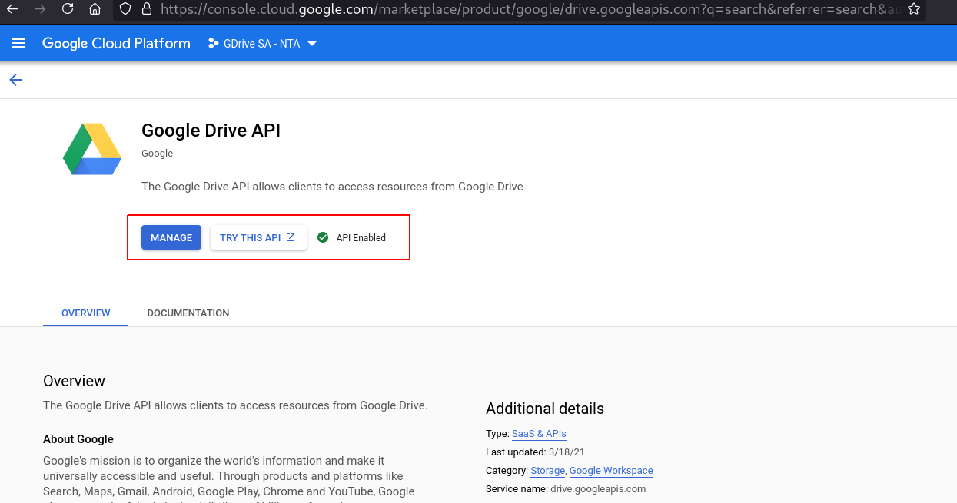

Create a service account
(Documentation reference: https://cloud.google.com/iam/docs/creating-managing-service-accounts )
- Go to the Service accounts page
- Select customer’s newly created project
- Service account name - google-drive-service-account
  - Create with default values

Create OAuth consent
- Inside the google drive API - Go to OAuth consent screen panel
- Choose “Internal” and click Create
- Name: Google Drive Service Account - {Customer name}
- Use “support@specterx.com” as developer email address and user support email.
- Click ‘Next’
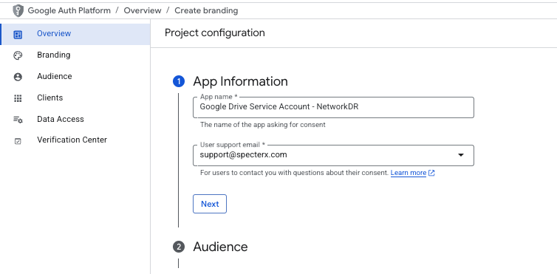
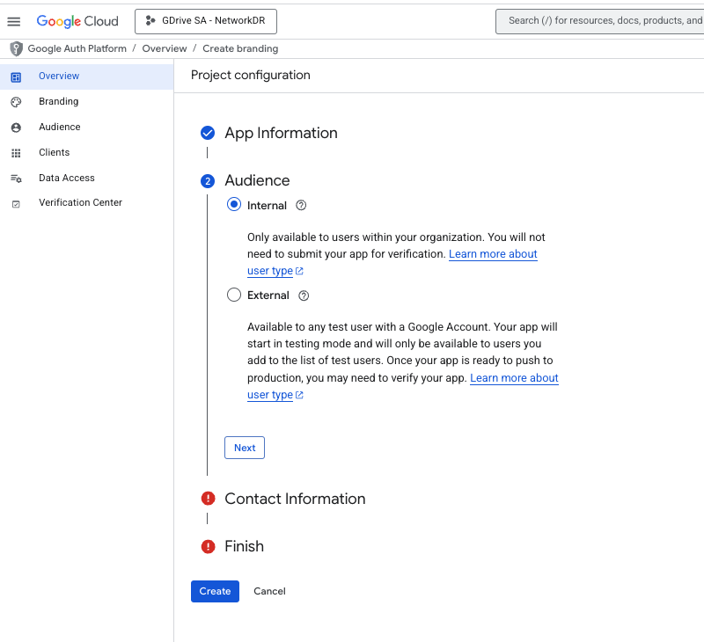
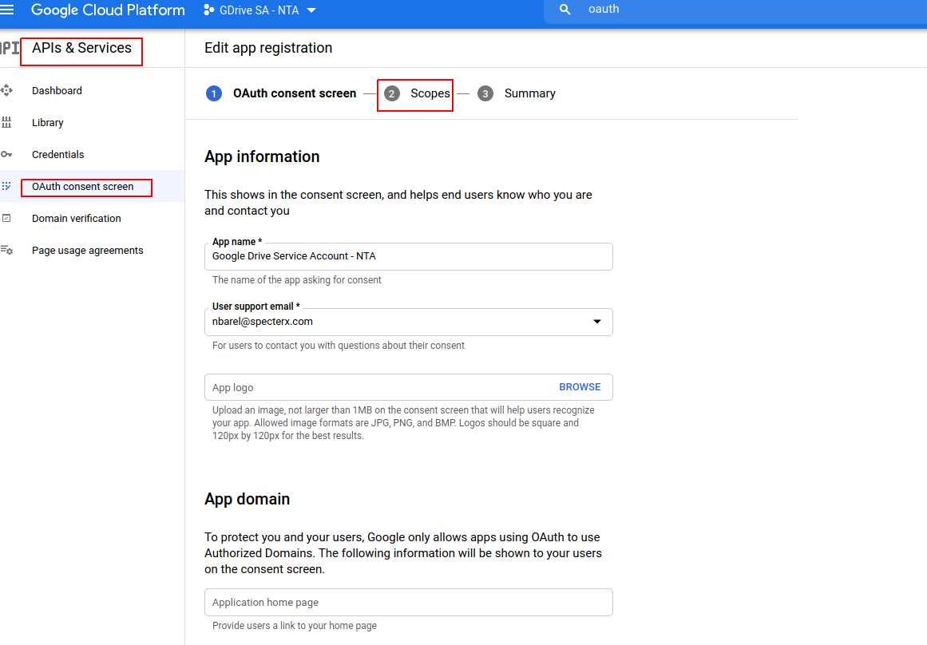

Save and continue!
- Go back to service account settings and enable Domain-Wide Delegation
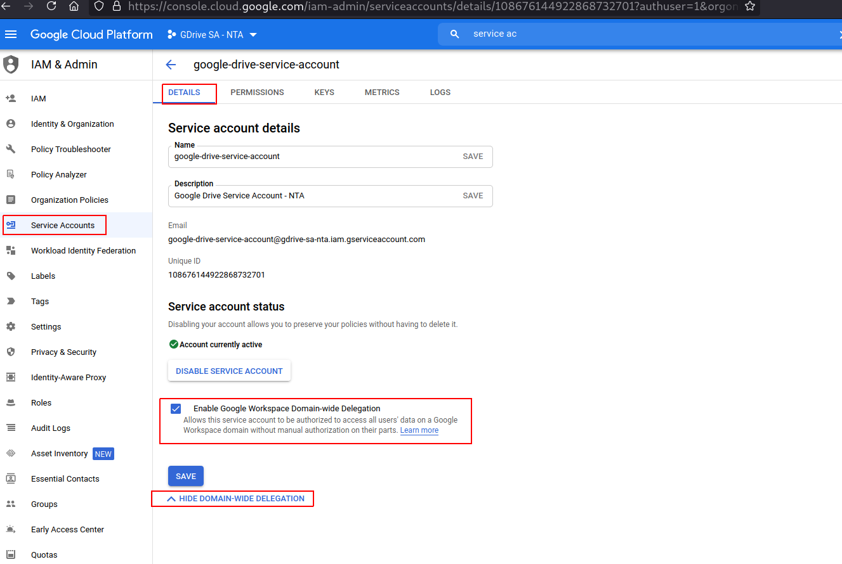
Above deprecated

- Create a key in JSON format and save it for later
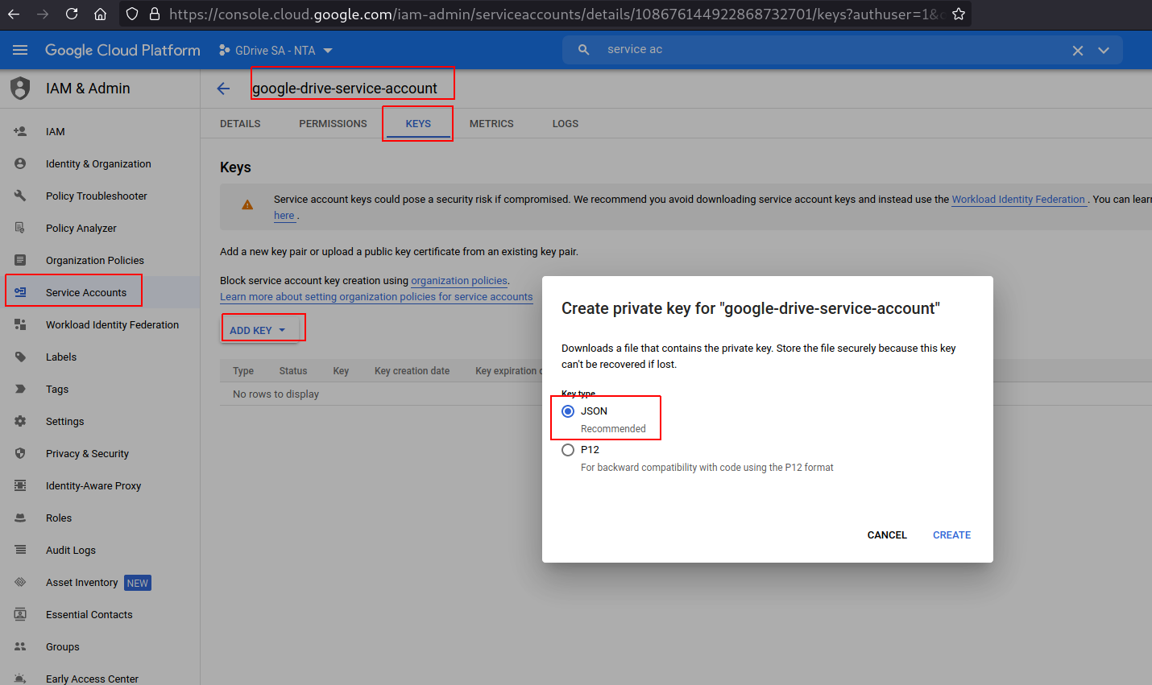
- Copy service account unique id for later

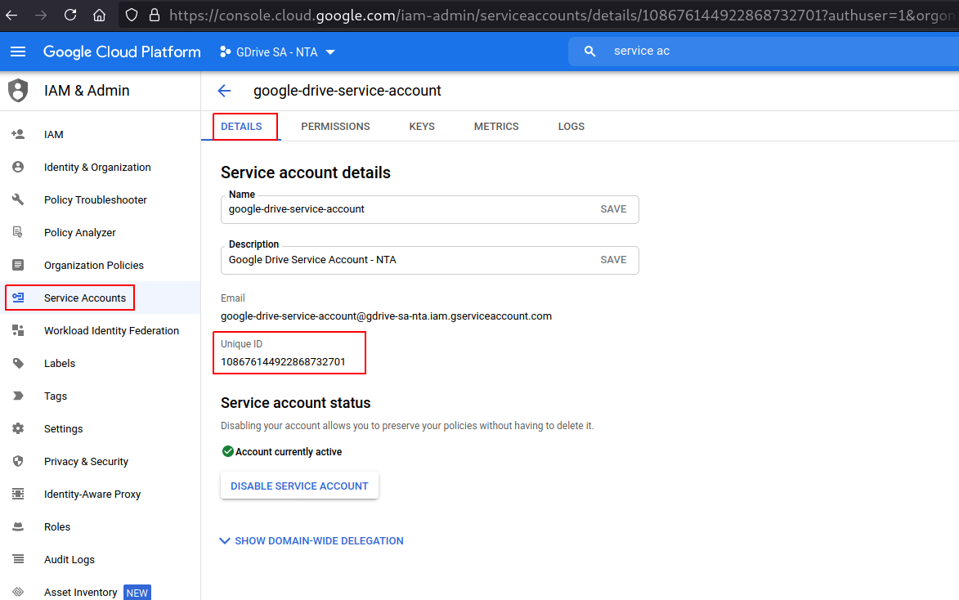

Create OAuth 2.0 Client ID
You will need this to update Google App ID in web-client (as per New Tenant provisioning document).

- This must be done from “GDrive SA - {customer}” project in Google Developers Console
- Browse to “APIs & Services” -> Credentials
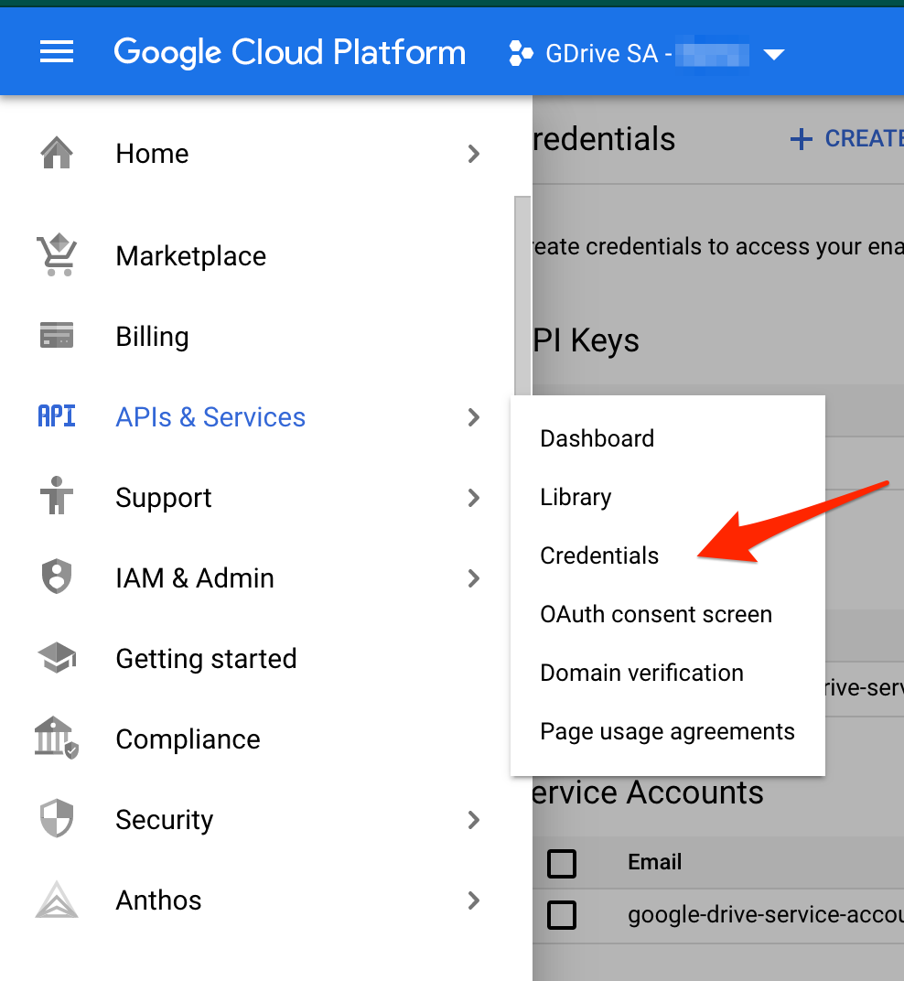
- Click on “+ Create credentials” and select “OAuth client ID”
  - Application type: Web application
  - Name: “SpecterX Web Client - {customer}”
  - Add a new “Authorized JavaScript origin”
    - https://{customer}.specterx.com
  - Add a new “Authorized redirect URI”
    - https://{customer}.specterx.com
    - https://{customer}.specterx.com/gdrive/share
    - https://{customer}.specterx.com/signin
    - https://{customer}.specterx.com/shared-file
After filling in the details, it should look like this:
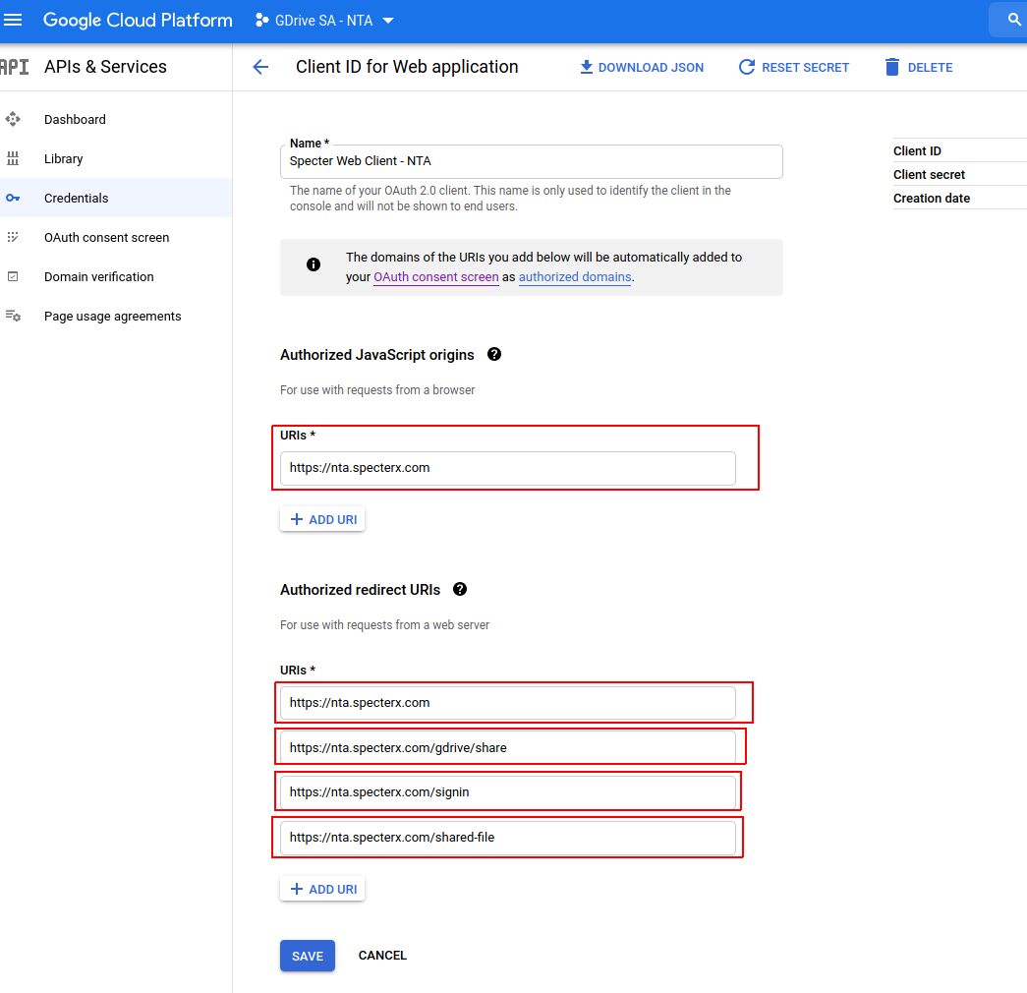
- Click “create”. You should see “SpecterX Web Client - {customer}” under “OAuth 2.0 Client IDs” now. Click it
- Copy and save the “Client ID” field value - this is the value for “APP_ID” attribute under “google” in web-client/src/config/env.js

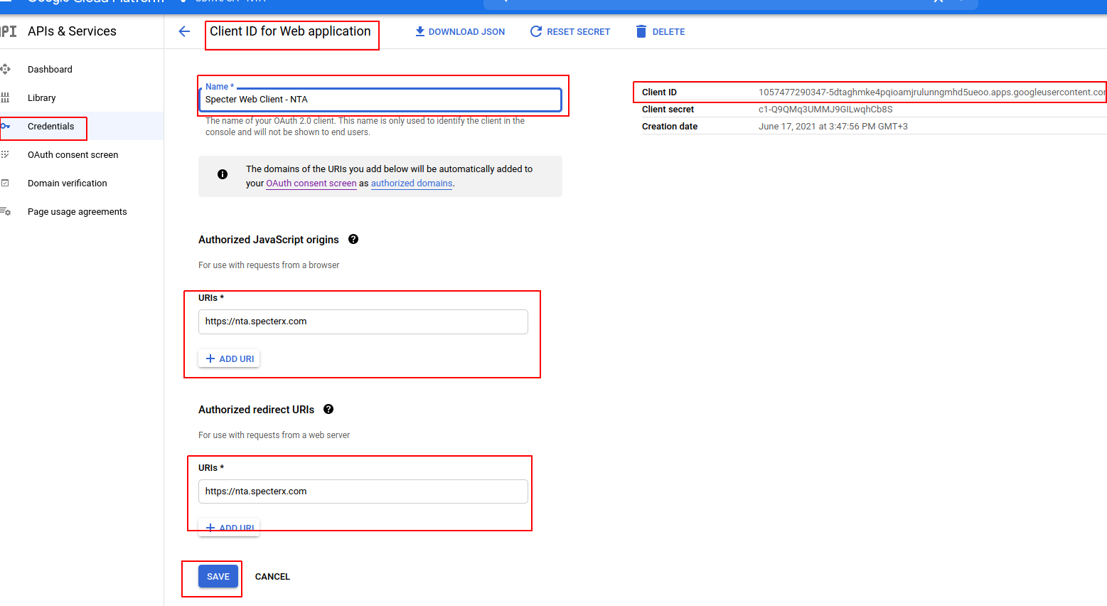

GSuite

Add service account scopes
- Go to GSuit Admin Console
- Gsuite > security > API control > Manage domain-wide delegation > add new
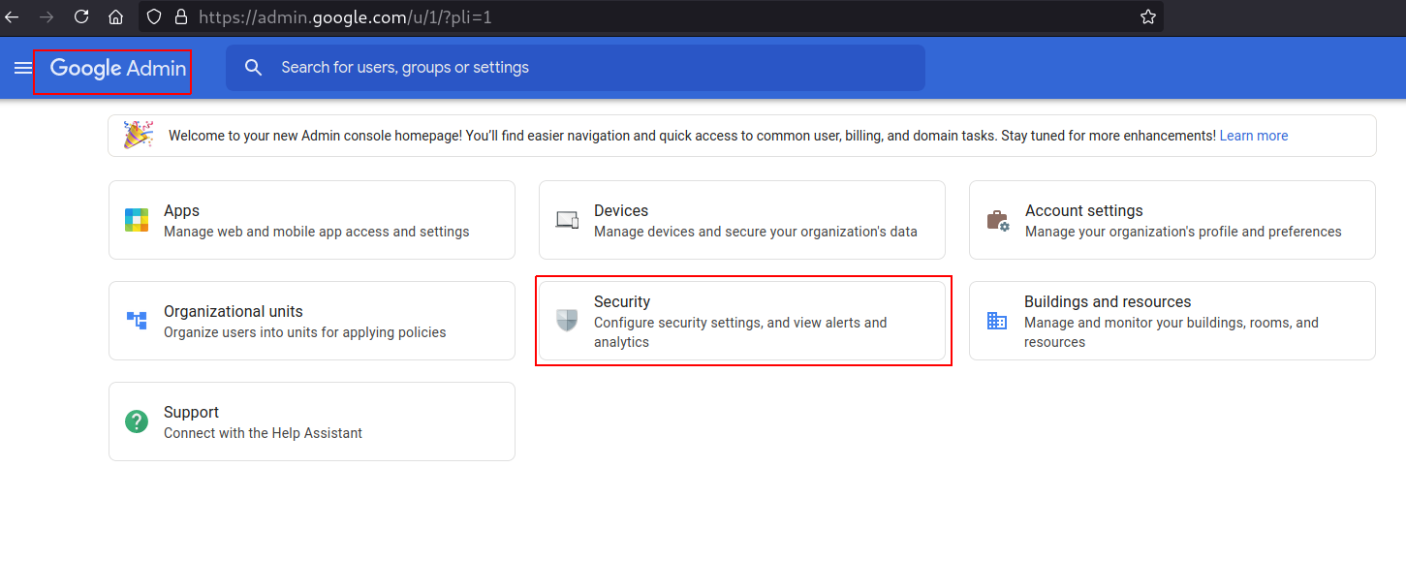
- Client ID - the service account unique id from the previous step
- Scope:
  - https://www.googleapis.com/auth/drive
  - https://www.googleapis.com/auth/drive.file

Create GSuite user
- Go to Directory -> Users
  - Click ’Add new user’
- Name:
  - {env}-secure-sharing@specterx.com
    - Save password
- Lastly, Put it under Services Accounts organization unit

Repositories

cloud_apps
- Take the JSON file we downloaded earlier and put it in common_modules repo: cloud_apps/google_service_account_private_keys/gdrive-sa-{env}.json
i.e - gdrive-sa-prod-ree
- Commit and push

Update configuration repo
- google_mediation_account - the email address of the GSuite user
- google_share_request_topic - the topic name from Google Developer console

Deploy configuration repo
Deploy download/access repo

